**SMART COMPOSTING DUSTBIN**

A Dhanush Kodi, S Dhanush Kumar, Gowthaman G, G Anandha Vignesh

R.M.K College Of Engineering and Technology

**A.Dhanush Kodi S.Dhanush Kumar.G.Gowthaman G.Anandha Vignesh K.Shailesh**

**RMK College Of Engineering and Technology**

**Abstract:**

* Smart Dustbin: This is an innovative system intended for effective and environment-friendly waste management. The method is supposed to turn organic waste into mineral Rich ash, which can further be processed to produce fertilizer that is of high quality. The dustbin consists of two chambers, one is for non-biodegradable waste, and the other is for biodegradable waste. Citizens are encouraged to separate their waste while disposing of it to ensure proper segregation.
* Once the biodegradable waste is dumped, sensors like ultrasonic and weight sensors monitor the fill level. When the waste attains 80% capacity of the bin, it is automatically transferred to the combustion chamber. There will be an integrated blades chop the waste into smaller pieces so that it is easier and faster to process. The combustion chamber is electrode-based and runs on electricity from a solar panel. The solar panel efficiently converts the solar energy into electrical energy, so the system is environmentally friendly and energy-efficient.
* Temperature sensors are fitted on the combustion chamber to ensure safe operation. If the temperature exceeds a predefined limit, the system pauses for cooling. An air blower is included to quickly lower the temperature and to supply the necessary oxygen for combustion. This ensures that the system operates safely and efficiently and also maintains a steady burning process.
* In a sense, the system controls its emission levels through activated charcoal filters, this helps to neutralize poisonous(harmful) gases and odors so that only clean, odor-free air is released back into the environment. These characteristics make it possible for such systems to be even used in densely populated locations.
* The mineral-rich ash produced during combustion is collected and can be processed into fertilizer, supporting sustainable agricultural practices.
* The Smart Dustbin also features a real-time monitoring system. It sends updates about the bin’s fill level, temperature, and process status to municipal authorities through a web application. It makes it easier for the authorities to manage waste collection and processing, reducing delays and ensuring timely intervention.
* By using solar panels as its primary energy source and integrating advanced technologies like electrode-based combustion, automated waste chopping, and emission control, the Smart Dustbin offers a sustainable solution to modern waste management challenges. It reduces the reliance on landfills, minimizes environmental impact, and encourages responsible waste disposal.
* This system is a complete package for promoting a cleaner and greener environment. Not only does it simplify the process of waste management but also turns waste into a valuable resource for the benefit of a sustainable future. Features such as renewable energy usage, safe and efficient combustion, cooling with an air blower, and real-time monitoring make Smart Dustbin a step forward toward creating smarter cities and a healthier planet.

**IMPACT:**

**Financial Viability:**

* Initial Investment: Lower profits in the first year due to innovative bin technology investment, leading to long-term cost savings and increased profitability.
* Long-Term Savings: Reduced landfill disposal costs and extended landfill lifespan.
* Revenue Generation: Selling high-quality manure from biodegradable waste.

**Social Benefits:**

* Cleaner Streets: Automated waste collection and segregation.
* Public Awareness: Educates communities on waste segregation and recycling.

**Operational Efficiency:**

* Real-Time Monitoring: Enhances waste collection efficiency.
* Scalable Solution: Suitable for various urban areas.

**Environmental Impact:**

* Reduces Landfill Waste: Converts biodegradable waste into manure.
* Promotes Sustainable Practices: Encourages composting and reduces carbon footprint.

**NOVELTY:**

**Odor Control:** During the decomposition and combustion of biodegradable waste, unpleasant odors are released. Activated charcoal adsorbs these odor-causing compounds, trapping them in its porous surface. This ensures that the surrounding environment remains odor-free.

**Neutralization of Harmful Gases:** The combustion process can release gases like methane or volatile organic compounds (VOCs), which are harmful to both the environment and human health. Activated charcoal traps these gases before they can escape into the atmosphere, making the waste conversion process more environmentally safe.

**Sustainability:** Since activated charcoal can be regenerated and reused after saturation (by heating it to release the adsorbed substances), it aligns with the Smart Dustbin’s focus on sustainability. This reusable nature reduces waste and ensures the system remains efficient in the long run.

**BLOCK DIAGRAM:**

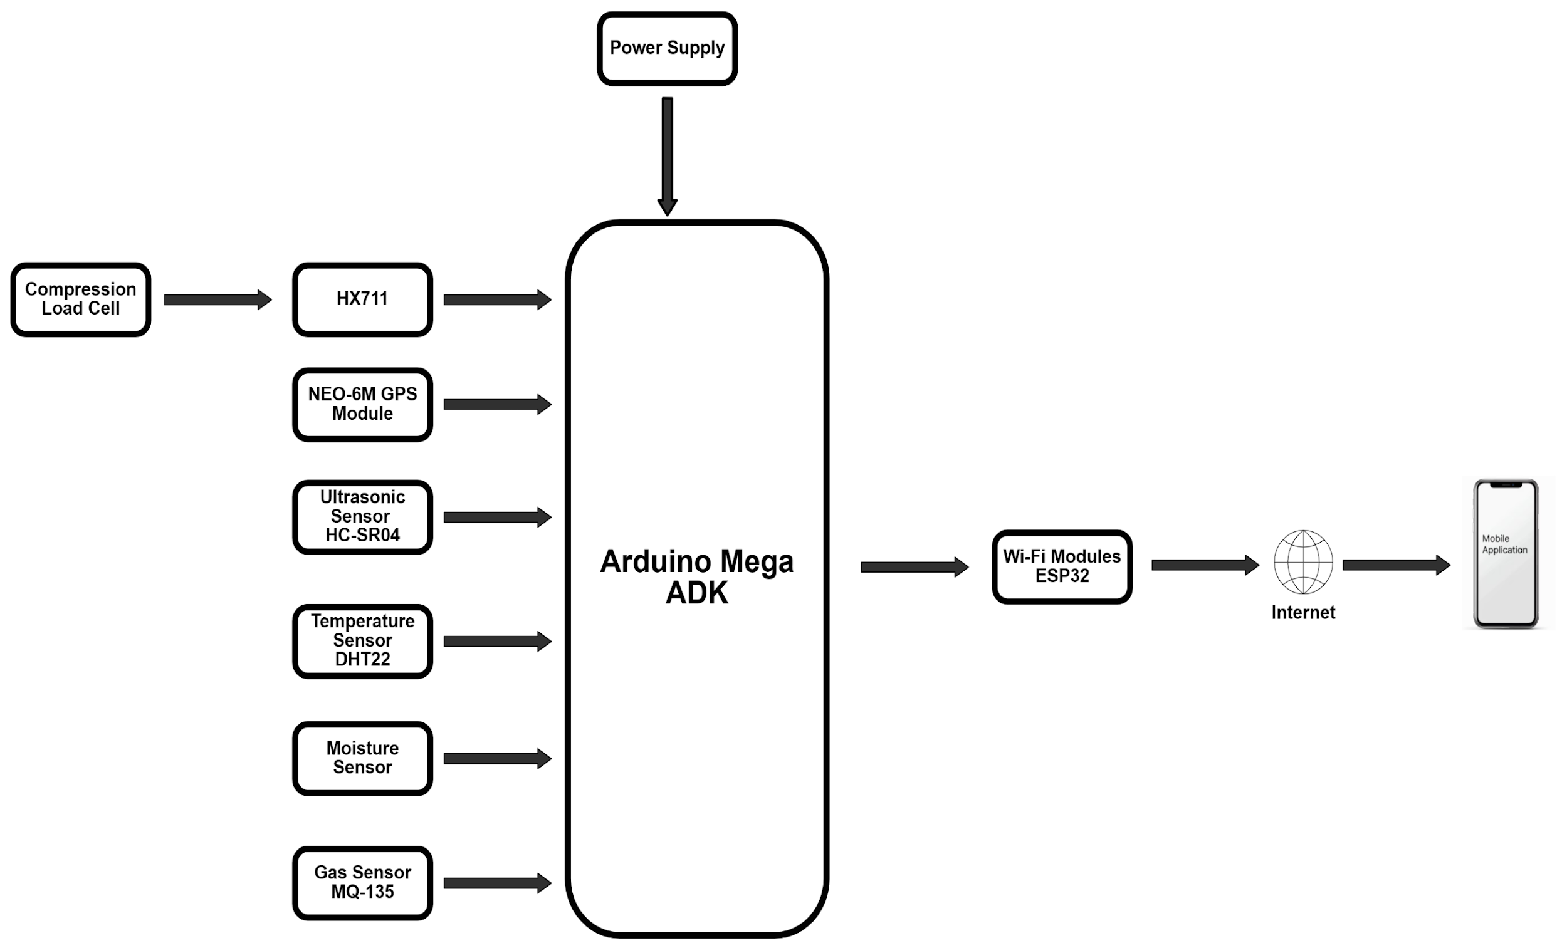

The hardware components chosen for this smart composting system are ideal for the task at hand. Here's why:

**Gas Sensor MQ-135**

Description: Detects harmful gases like ammonia, methane, and other volatile organic compounds (VOCs) produced during composting.

**Ultrasonic Sensor HC-SR04**

Description: Measures the distance to an object by sending an ultrasonic pulse and measuring the echo. Used to detect the fill level of the bin.

**Moisture Sensor**

Description: Measures the moisture level of the compost to ensure optimal conditions for decomposition.

**Temperature sensor DHT22**

Description: Measures the temperature and humidity inside the composting chamber to ensure it stays within the ideal range for composting.

**NEO-6M GPS Module**

Description: A widely used, low-cost GPS module that provides accurate location data

**Compression Load Cell**

Description: Designed to measure compressive forces, these load cells are ideal for applications where the bin can be placed directly on top of the sensor.

**PARTIAL IMPLIMENTATION:**

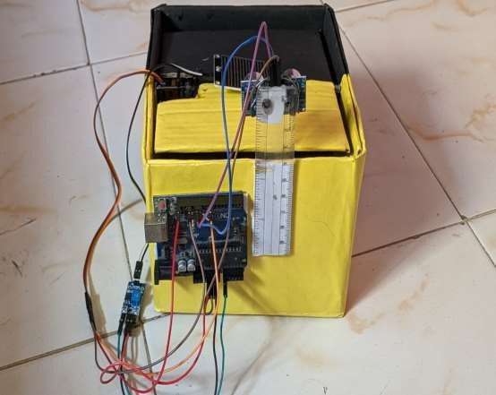

**FLOW DIAGRAM:**

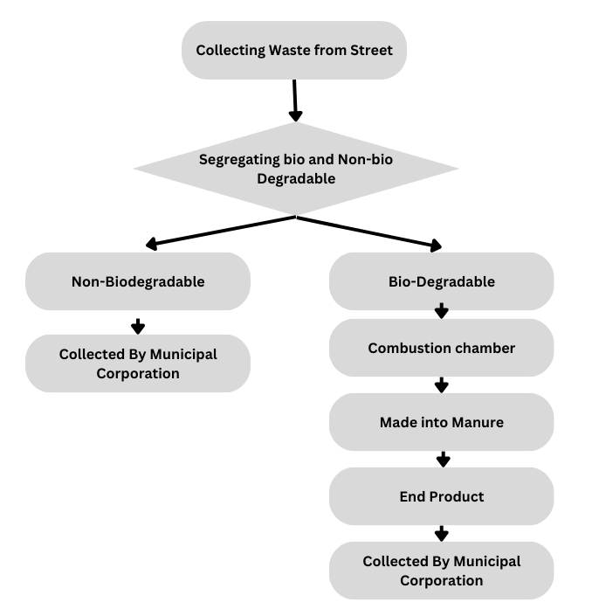

**CONSTRUCTION:**

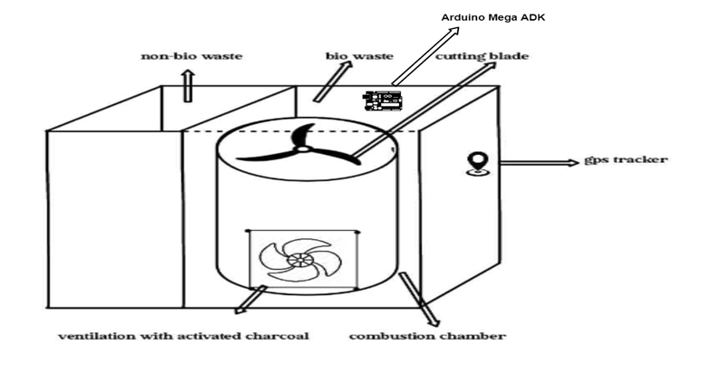

**Hardware Details:**

**Hardware Components and Their Description**

1. **Sensors**:
   * **Gas Sensor (MQ-135)**: Detects harmful gases such as ammonia, methane, and volatile organic compounds (VOCs) released during composting.
   * **Ultrasonic Sensor (HC-SR04)**: Measures the fill level of the bin by calculating the distance to the waste.
   * **Moisture Sensor**: Monitors the moisture content in the compost to maintain optimal decomposition conditions.
   * **Temperature Sensor (DHT22)**: Tracks temperature and humidity inside the combustion chamber to ensure safe and efficient operation.
2. **Combustion Chamber**:
   * **Heating Element**: Provides the necessary heat for processing waste into mineral-rich ash.
   * **Activated Charcoal**: Filters harmful gases and neutralizes odors during the combustion process.
3. **Microcontroller and Modules**:
   * **Arduino**: The central controller that manages the operations of sensors, motors, and other components.
   * **NEO-6M GPS Module**: Tracks the bin’s location for better waste management logistics.
   * **Wi-Fi Module**: Enables real-time communication with municipal authorities by transmitting updates such as fill level and temperature data.
4. **Solar Panel & Battery**:
   * Converts solar energy into electricity to power the system, ensuring energy efficiency and sustainability. The battery stores the energy for continuous operation even in low-light conditions.
5. **Compression Load Cell**:
   * Measures the weight of the waste in the bin to monitor the fill level accurately. These sensors support weight ranges from 20kg to 100kg and are essential for automating waste transfer processes.